7. Water Balance and Excretion of Nitrogenous Wastes *Ch 38, 47, 48*

______________________________________________________________________________

I. Introduction *(921-926, 1118)*

A. Homeostasis

B. Body Fluids

1. Fluid compartments

2. Osmosis

II. Solute and Water Balance *(1119-1132)*

A. Paths of Water Flux

1. Water gain

2. Water loss

B. Physiologically Wet and Physiologically Dry Habitats

1. General definitions

2. Marine environments

3. Freshwater environments

4. Terrestrial environments

C. Osmoconformers versus Osmoregulators

III. The Vertebrate Liver and Homeostasis *(1108, 1120-1121)*

A. Structural Relationship to Circulatory System

B. Regulation of Blood Sugar Level

C. Production of Nitrogenous Wastes

1. Protein catabolism

2. Ammonium ions, urea, and uric acid

3. Relationship to environmental physiology

D. Osmoregulation and Nitrogen Excretion

IV. Osmoregulatory and Excretory Systems *(1123-1132)*

A. Insects

1. Effects of an open circulatory system

2. Malphigian tubules

B. The Vertebrate Kidney

1. General structure

2. General function

C. Freshwater and Marine Fishes

D. Mammals

7-1

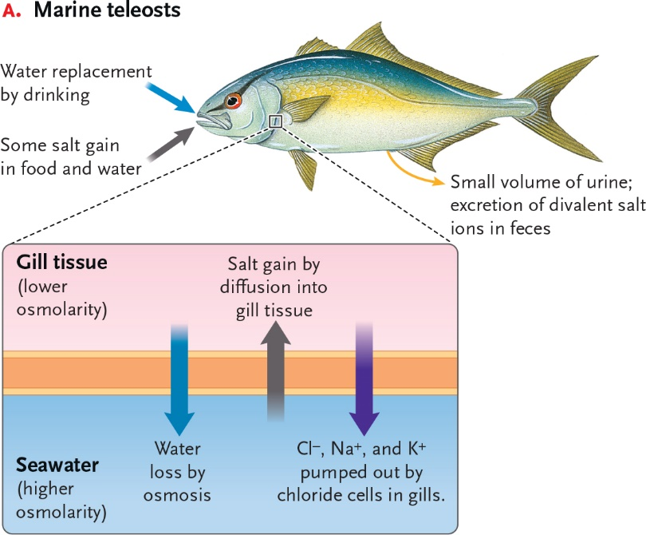

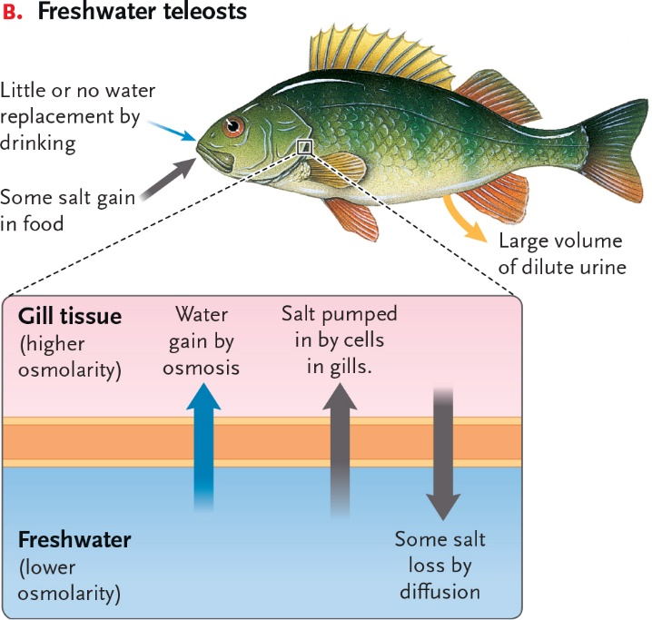

7-2

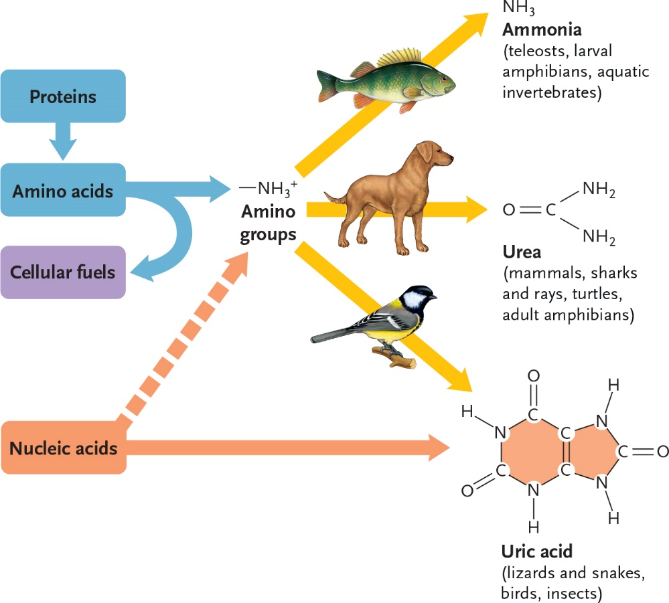

____________________________________________________________

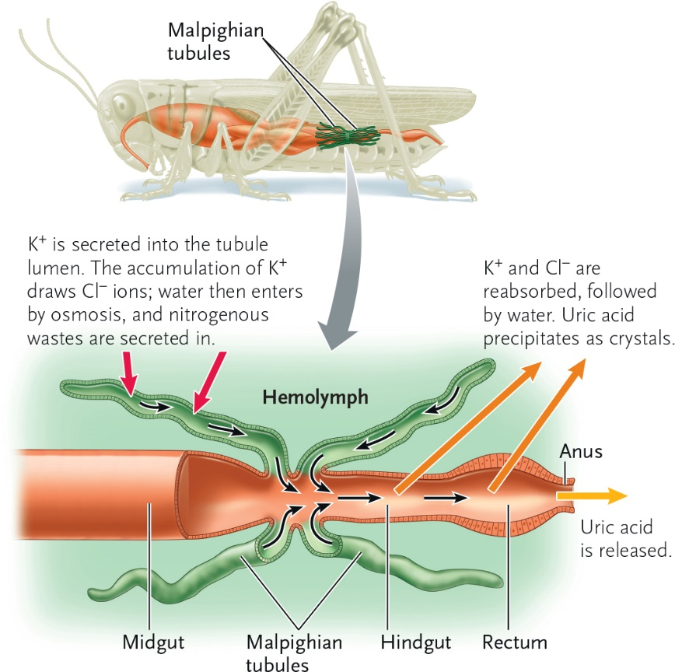

7-3

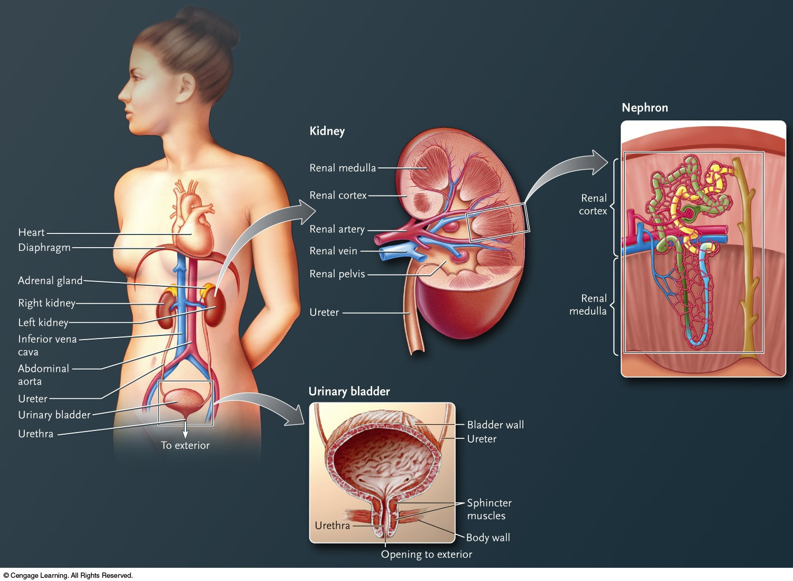

7-4

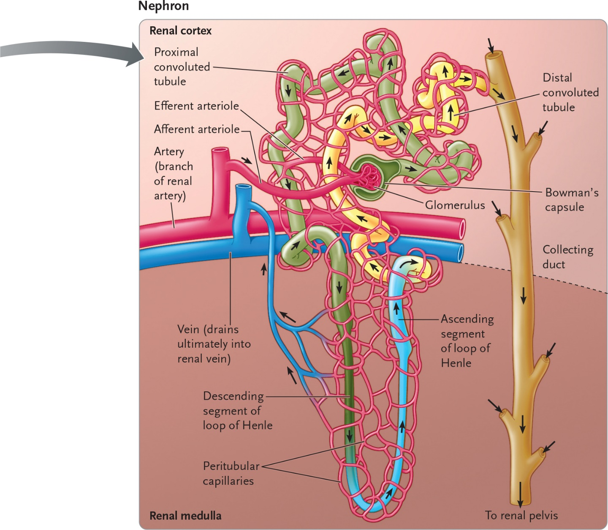

7-5

